**CSE103L Circuits & Systems-I Lab**

**Circuits And System 1**

**LAB REPORT # 11 &12**



2020

**Submitted to:**

**Engr. Faiz Ullah**

**Submitted by:**

**TAYYABA**

**Registration No:**

**19PWCSE1854**

**Semester: 2nd**

**Class Section: C**

“On my honour, as student of University of Engineering and Technology, I have neither given nor received unauthorized assistance on this academic work.”

Student Signature: ______________

Friday, July 24, 2020

**Department of Computer Systems Engineering**

**University of Engineering and Technology Peshawar**

**ASSESSMENT RUBRICS LAB # 13**

**Complex Circuit Analysis using MATLAB**

|  |  |  |  |  |
| --- | --- | --- | --- | --- |
| **LAB REPORT ASSESSMENT** | | | | |
| **Criteria** | **Excellent** | **Average** | **Nill** | **Marks**  **Obtained** |
| **1. Objectives of Lab** | All objectives of lab are properly covered [Marks 0.5] | Objectives of lab are partially covered  [Marks 0.25] | Objectives of lab are not shown [Marks 0] |  |
| **2. Complex Circuit (Theory, Circuit Diagram )** | Brief introduction about Complex Circuit (How to apply KVL equations in each mesh) is shown along with properly labeled circuit diagram  [Marks 2] | Some of the points about Mesh Current Analysis are missing and circuit diagram is not properly labeled  [Marks 0.5] | Introduction about complex circuit and circuit diagram is not shown [Marks 0] |  |
| **3. MATLAB** | Brief introduction of MATLAB  [Marks 1] | Brief introduction of MATLAB Is not shown  [Marks 0] | |  |
| **4. MATLAB code** | All experimental code of MATLAB is shown [Marks 3] | Some of the codes are missing [Marks 1.5] | Full codes are missing [Marks 0] |  |
| **5. Comparisons of MATLAB and PSpice** | Results are verified [Marks 2.5] | Results are not verified [Marks 0] | |  |
| **6. Conclusion** | Conclusion about experiment is shown [Marks 1] | Conclusion about experiment is partially shown [Marks 0.5] | Conclusion about experiment is not shown  [Marks 0] |  |
| Total Marks Obtained:  Instructor Signature: | | | | |

**Objectives:**

# Complex Circuit Analysis using MATLAB

* To understand Mesh Current Method
* To get hands on experience of working on complex circuit with PSPICE.
* To get familiar with MATLAB Environment.
* To be able to write programs in MATLAB that solves matrices.

# Apparatus:

Computer with PSPICE and MATLAB software installed on it

# Complex Circuit:-

In theory, any circuit which cannot be categorized as simple series or parallel circuit is called complex circuit. You cannot solve complex circuits using simple series-parallel equivalence. The circuit on the right is a complex circuit because here R1 and R2 are not in series since same current doesn’t flow through them and they are definitely not parallel. R1 and R3 are neither in series nor parallel. Such circuits are called complex circuits. For complex circuits we have KCL and KVL. When we apply KCL at every node whose voltage is unknown we get n equations in n unknown and then their solution gives us required voltage values. This is called Node voltage method. When we apply KVL in individual loops we get n equations in n unknown currents. Their solution gives us values of currents. This is called Mesh current method. Both mesh and node methods are used to analyze complex circuits.

## Circuit Daigram:-

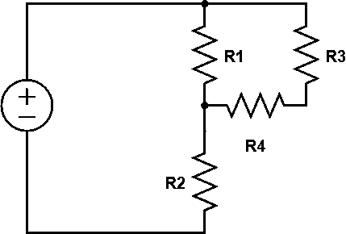

**MATLAB:-**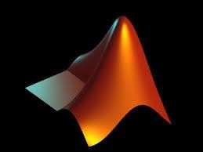 MATLAB is a multi-paradigm numerical computing environment and proprietary programming language developed by Math-Works. MATLAB allows matrix manipulations, plotting of functions and data, implementation of algorithms, creation of user interfaces, and interfacing with programs written in other languages.

# Schematics:-

We will draw the following circuit using Pspice:-

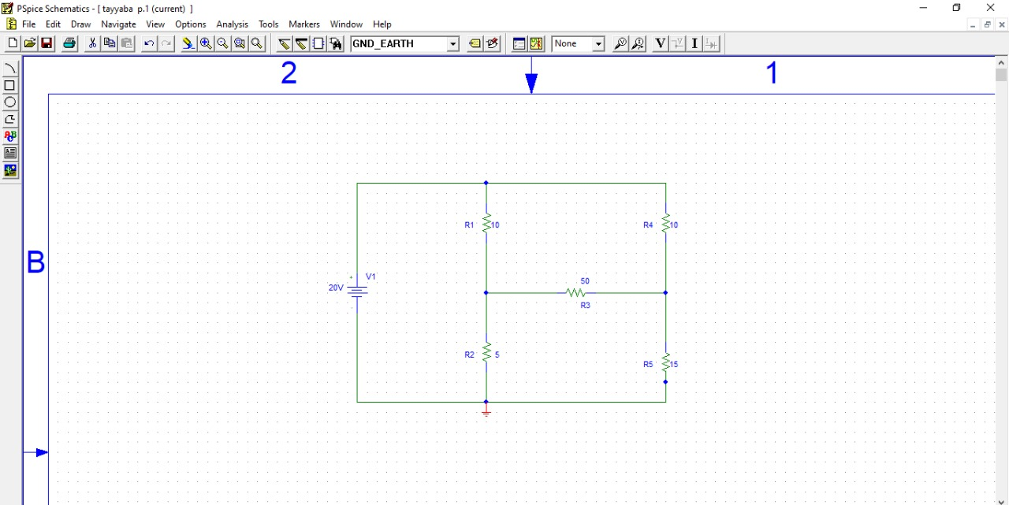

Using Mesh Analysis on the circuit:



**L3**

**L2**

**L1**

## For Loop 1:-

-20 +10 (I1 – I2) + 5(I1 – I3) = 0

## 15*I1 - 10*I2 – 5*I3 = 20 →(i)

**For loop 2:-**

10*I2 + 50(I2 - I3) + (I2 – I1) = 0

## I1 + 51*I2 – 50*I3 = 0 - →(ii)

**For Loop 3:-**

50(I3-I2) + 15*I3 + 5(I3 – I1)= 0

## -5*I1 – 50*I2 + 70*I3 = 0 →(iii)

**We got three equations:-**

15*I1 - 10*I2 – 5*I3 = -20

-10*I1 + 70*I2 – 50*I3 = 0

-5*I1 – 50*I2 + 70*I3 = 0

# MATLAB Code:-

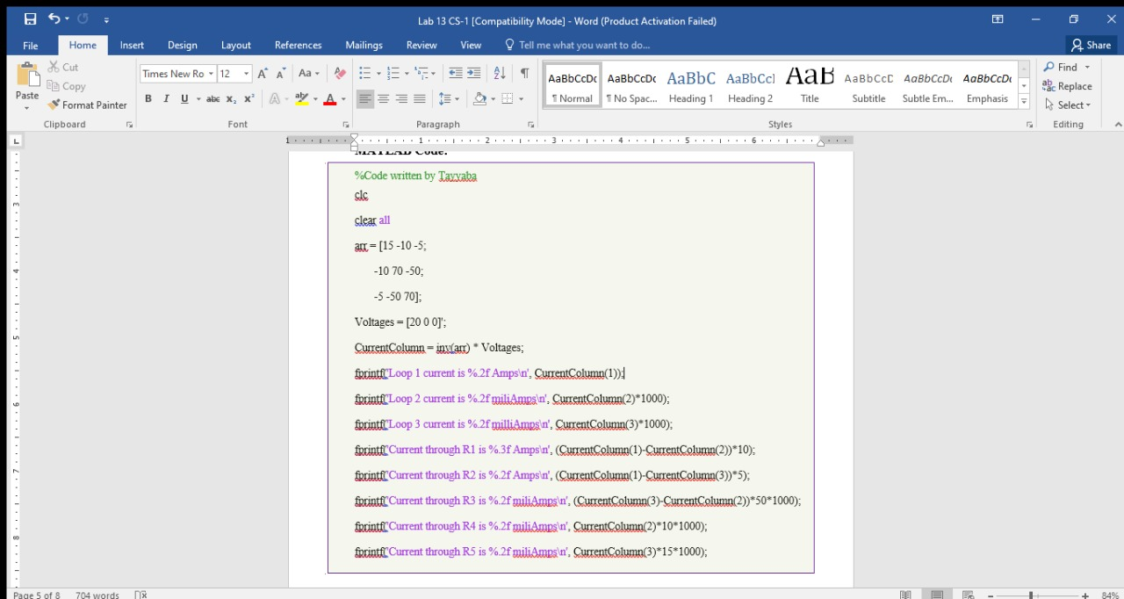

**Output:-**

* **Matlab:-**

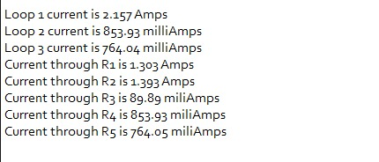

**Pspice:-**

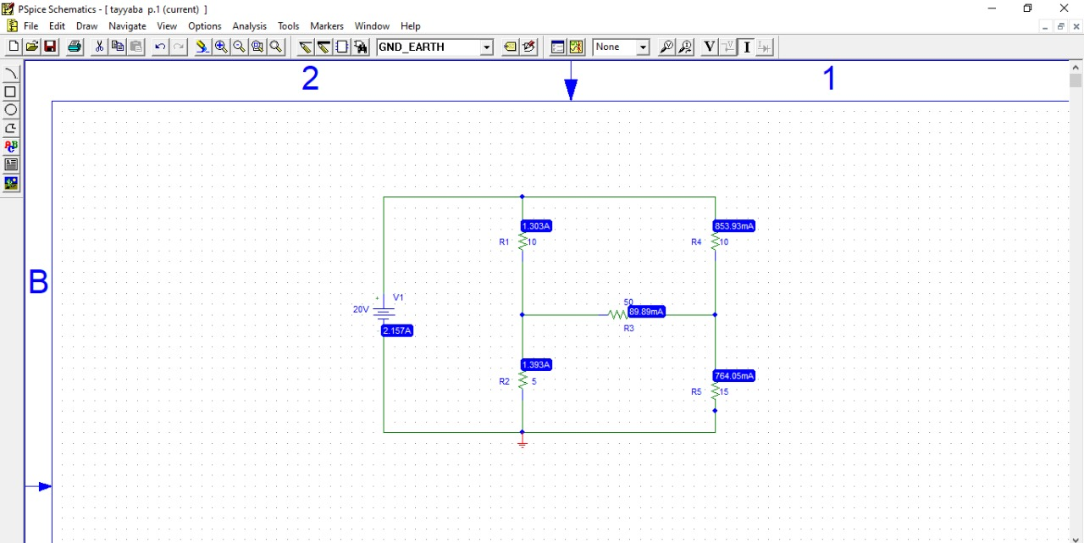

**Observation & Calculations:-**

The figures are rounded to number decimal points that PSPICE was showing. For instance since PSICE shows current though R1 in amperes and to 3 decimal places while current through every other resistor is shown in milliamps to 2 decimal places, I programmed MATLAB to show the same format. This is why some MATLAB currents are in amperes and some are in milliamps.

|  |  |  |
| --- | --- | --- |
| **Resistor** | **Current Through** | |
| **MATLAB Value** | **PSPICE value** |
| R1 | 2.936 A | 2.936 A |
| R2 | 2.413A | 2.413 A |
| R3 | 522.79 mA | 522.79 mA |
| R4 | 643.43 mA | 643.43 mA |
| R5 | 1.166 A | 1.166 A |

**Conclusion:-**

After comparing values of MATLAB and PSPICE Outputs, we get similar outputs. Thus verification of complex circuit is verified using MATLAB and PSPICE.